Media Kit
Norman Wilkinson – Q & A/ Tip Sheet

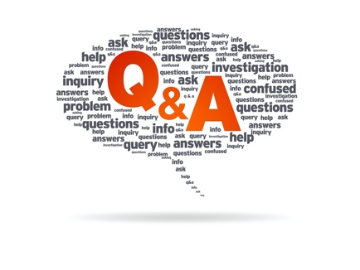
Q: Why did you self-publish?
A: This is my first publication. I have no agent, so I thought I would test the water this way before deciding what to do next.

Q: Who are your favourite writers?
A: My tastes are many and varied. I like historical novels, for example Manda Scott’s series on Boudica, Patrick O’Brian’s Aubrey-Maturin series, anything by Neil Gaiman, but my all-time favourite is Rudyard Kipling’s The Jungle Book and many of his short stories.

Q: Where did you get your ideas?
A: From being in Antigua itself and real-life encounters with mongooses there. Put this together with the island setting and a dash of Rikki-Tikki-Tavi and there you go!

Q: Is SUGAR and SNAKES a children’s book?
A: It is aimed at being ‘young adult’ rather than children, although the language used is clean, it is mainly because some of the subject matter involves war, death and blood which I think are not suitable for the younger audience.

Q: If this is PART I – what others are coming?
A: I have sequels in mind but I have not put pen to paper yet. I want to see what the interest level is first of all.

Q: Are you available for interview?
A: Yes definitely.

Q: Is it available as an audio book?
A: No, not at this time but I am open to the idea.

© 2020 Norman Wilkinson

